TRF 10 B: REVISION: 01
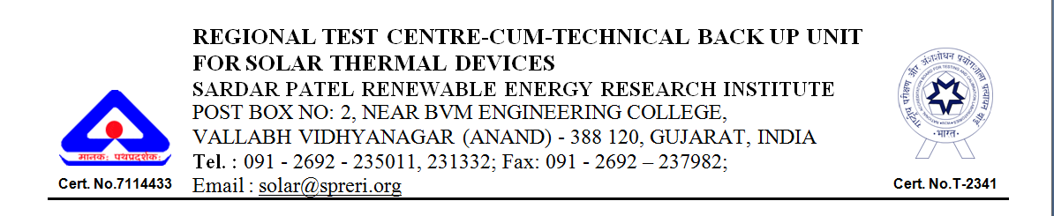
ONLINE APPLICATION FORM
TEST REPORT FOR BOX TYPE SOLAR COOKER (SBC) WITH MIRROR REFLECTOR AS PER IS NO. 13429: 2000 WITH ALL APPLICABLE AMENDMENTS

From: -
Company (Please write complete Postal address)

Dear Sir,
We hereby place an order on you for the services as described below:
Sr. No. | Description | No. of  samples | Test Fee per sample (Rs.) | Total  ( Rs)
1. | Solar Cooker (Box Type) |  | 8,000/- (Direct)  5,000/- (BIS)
- A Bank Draft No. ________ dated _________ for Rs. _________ in favour of Sardar Patel Renewable Energy Research Institute payable at Anand/ Vallabh Vidhyanagar drawn on _______________________ is enclosed towards the Test Fee for the sample(s).
- The manufacturer/supplier should submit the general specifications of the test sample as per Annexure –I (enclosed).
- The manufacture/supplier should provide list of components to be submitted along with Test sample as per Annexure -II (enclosed).
- Test Sample along with Annexure-I including the demand draft is handed over to the above mentioned address.
- We accept general terms and conditions enclosed with this application.

Signature of authorized person
Name (Capital Letters):
Designation:
Seal of the Company:
Dated:

For office use only

Date & time of Receipt: Inspected By:

Remarks if any: Sample Identification Number (I.D.)

Signature of Receiving Authority:

ANNEXURE - I
Information on Solar Box Cooker (SBC)
- GENERAL
Name & address of manufacturer/supplier/ importer

Registration no.
Contact details of:
- E-mail
- Website
- Phone no (office, works/factory)
- Mobile no.
Details of collaborator (if any)
- Name & address of collaborator

- Name of the component being
imported

- SPECIFICATIONS OF THE TEST SAMPLE
(All dimensions are in mm, unless specified otherwise)

B1. SYSTEM DETAILS
Make/ model
Serial No.
Date/ month/ year of manufacturing

B2. COVER PLATE
No. of glazing
Material (Tempered or Toughened glass)
Spacing between outer and inner plates
Glass thickness
Aperture area, m²

B3. COOKER BOX
Material
Size (Length × Width × Height)
Thickness, mm | GS : 0.45  Al : 0.5  FRP : 1.0

B4. COOKING TRAY
Material
Thickness
Size :
a) Upper
b) Lower
Depth
Paint on inner surface

B5. INSULATION
Material
Coefficient of thermal conductivity at 100°C
Thickness
- Sides and edges
- Back

B6. GASKET & SEALENT
Material
Thickness

B7. REFLECTIMG MIROR
Size
Thickness

B8. COOKING POTS WITH LID
Material
Number
Thickness
Depth
Diameter
Total capacity of the pots in liters
Coating on outside surface

- TESTING FEE DETAILS
Name & address of the issuing bank
Bank draft no. & date
Amount | Rs.

D. ANY OTHER INFORMATION

Declaration
This is to certify that the above-furnished information is true to the best of my knowledge and belief. The RTC, SPRERI or its authorized nominee will be free to visit our works in order to assess the details provided above by giving an advance notice in writing.

Date:
Place: Signature with Seal

NB: To be signed by officer not below than rank of G.M./Equivalent.
ANNEXURE - II
List of components/ information to be submitted along with the sample

A fully assembled unit of Solar Box Cooker | 1
Cooking tray material (50mmx50mm) | One piece
Cooker box material ( 50mm x 50mm) | One piece
Gasket/sealant of about 200 mm length | One piece
K-value certificate of insulation material | Photocopy

GENERAL TERMS AND CONDITIONS
- The manufacture/supplier should supply the system as per the specifications and will take back the system at their own cost after the issue of Test Report within three months.
- For identification purpose, all components supplied to the Centre for testing purpose shall be marked clearly.
- RTC, SPRERI shall not be responsible for any loss or damage caused to the sample if any, during the testing of the system.
- RTC, SPRERI is only a testing centre and not a certifying authority and the results reported are valid under stipulated conditions of measurements.
- A copy of the Test Report containing all the parameters measured at RTC, SPRERI as per the BIS specifications and claims made by manufacturer/supplier will be issued to the manufacturer/supplier/importer.
- The report contains the following DISCLAIMER:
- This is a Report on measurements carried out on the samples submitted at RTC, SPRERI.
- The TEST REPORT refers only to the sample supplied. The results presented here relate only to the conditions of the measurements at the time of testing.
- RTC, SPRERI does not accept any liability for any consequences including commercial or otherwise arising out of the utilization of the information contained in the Report.
- Any queries related to this Report will not be entertained after one month of receipt of this report.
- This Test Report is not a legal document and is not valid for any kind of legal Formalities.
- The Test Report in full or in part may not be published or advertised or used for any legal action unless prior permission has been secured from this Test Centre.

CHECKLIST BEFORE SUBMISSION OF TEST SAMPLE OF SOLAR BOX COOKER (SBC)
- Information duly filled in Annexure-I
- List of components/information submitted along with the sample as per Annexure-II

